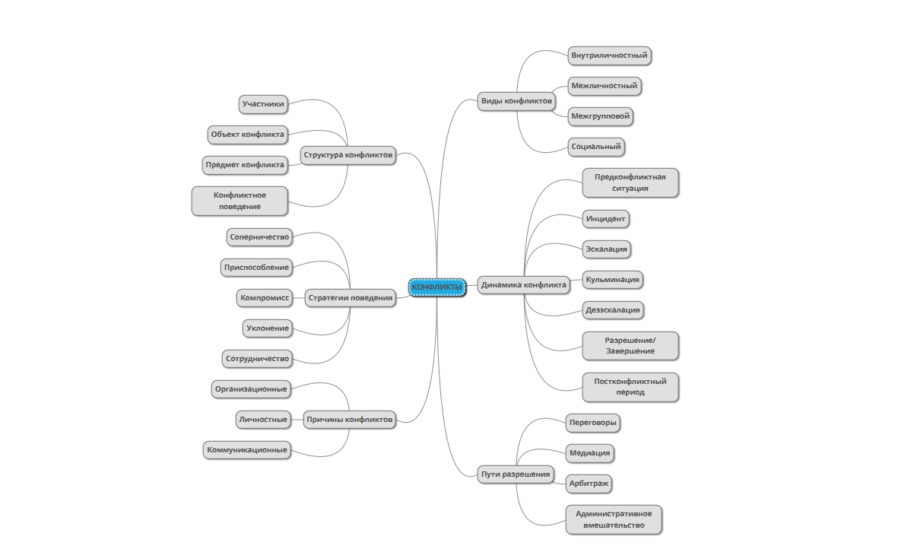

https://app.mindmup.com/map/_free/2025/09/79b262e09c6111f083fca345c3d69d64